Developer Diary | Stoyan Rizov

**Game Description:**

The game is going to be about an evil scientist who is trying to escape from an underground lab by reaching the escape hatch at the top of the building. The player will use a megaphone (microphone) in order to jump or climb the platforms to reach the top of the building. The sound or level of the microphone will determine the force of the jump. The player will have to face difficulties such as fighting enemies along the quest of escape, increase of difficulty with enemies the higher the score (platforms reached) and another difficulty the player must face is to the increase in speed therefore the player will have to react quicker on climbing the platforms over time. Controls for player movement will be using an accelerometer & microphone.

**Week 1 & 2 Summary:**

The first thing I ever do when it comes to designing and creating games is player controls & player character, so I will complete that first before moving on to designing the scene. I researched on where to create characters for unity. I was able to find a very useful website allowing you to draw the character and then download it in any format desirable, I designed the scientist and downloaded as png format, I then imported it into unity. The second task as I mentioned creating the player movement script, I created very simple script just to be able to test the game.

Difficulties: The main difficulty that I am going to have is developing controls for the player so because it is the start of the development time, I will not create them yet so that I can test all the functions properly and easier.

Decisions: I decided to create a simple movement script instead to save me a lot of time testing and developing the game.

**Week 3 & 4 Summary:**

Player movement and character was designed therefore I can now move on to the scene development such as the platforms and the background along with it. Designing the platforms to randomly spawn was a bit more difficult than I thought but at the end I was able to get it to work. I will use List <> to store them & randomly generate them (spawn). I created an empty object in to the scene and named it level manager in order to control the platforms (from the platform script).

Difficulties: The difficulty here is the fact that I can’t just design the maps (scenes) because this is going to be and endless game therefore the platforms must be spawned at random & they have to be randomly generated and infinitive.

Decisions: After a long period of research I was able to come up with the right script to do so, making the whole game very addictive and competitive as the platforms will be never ending so the score that I will be designing in the future will make it competitive.

**Week 4 & 5 Summary:**

Once I had the platform perfectly working it is now time to add score to the game, timer & player death. I was able to calculate the score when the player has stepped on a randomly generated platform. I then started designing the camera script as I was able to count score when the player is on a platform but now, I need the camera to be able to follow me as I go up so that I can have a smooth camera movement & have a death screen as the player falls off a platform. Once I decided on the camera follow It is now time for me to ahead with player death, so I added a few if statements in my camera follow script so that when the player is off the screen the game will reset. I also added timer in the start method setting it to 0 and then increasing it in the LateUpdate method with speedMultiple variable that I used for setting how quick the camera will follow so that will increase as time increases making it more difficult for the player.

Difficulties: I researched a lot when it came to camera following not for its difficulty but I wanted to get the best movement best frames possible as there is a lot when it comes to smoothness of the camera and a lot of different methods on doing so for example whether to use update or fixed update just as an example as it all matters also on the performance.

Decisions: I decided to use as simple as possible instead of over complicating everything, I used late update when it came to camera follow as LateUpdate is called every frame and it should always be used for CameraFollow.

**Week 5 & 6 Summary:**

I can now do the GameManager script in order to manage player death including the animation for game over, play again option (menu), main menu therefore this week I will be working on the menus. I created another scene so that I can access main menu in game and will be the starting scene of course of the game. I then added a pause button allowing the player to pause the game using time.timescale = 0.0f ,which is accessed in the GameManager script. In the pause menu I have options and main menu, in the options menu I added sensitivity volume (microphone). Sensitivity volume is stored in the device using PlayerPrefs so that the user can store their settings and not have to adjust it every time. Now that I have main menu scene created, I moved on to creating high score storing it to PlayerPrefs and comparing it to current highest score (if statement) and if its bigger to be stored and displayed.

Difficulties: I had a bit of difficulty when it came to the menus as it does take a lot of time to design, create onclick events and make it work. I had trouble with pause menu as it would pause the game, but the character wouldn’t pause. 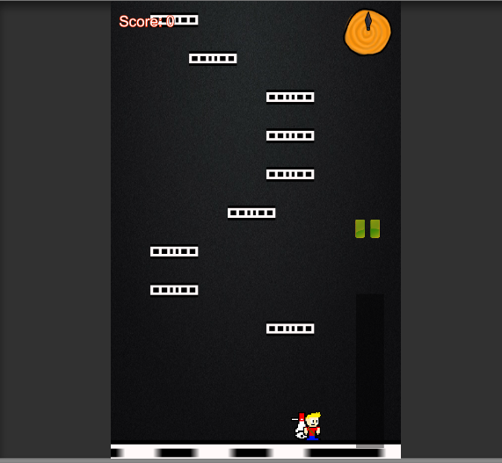

Decisions: I researched more regarding that and figured out the simple solution to remove character object when pause is active.

**Week 6,7 & 8 Summary:**

I Added enemies + enemy spawn script and made animations for the enemies also when the player reaches 50,100,150,200 (score) the enemies will increase therefore making the game difficulty increase. All the menus were completed so the next step is to get the player to jump using sounds created by the microphone and the player to be able to turn left and right using accelerometer. I was able to get the accelerometer working surprisingly easy. There was not much information when it came to the microphone script, but with a long research I was able to find it and make it work.

Difficulties: Definitely the most difficult part of this project was the microphone as I spent the last week researching and trying to find out a way to make it so that it reads only when spoken to but then again there was a massive problem because I made it so it only responds if the player has a certain loudness but what if he kept the same tone , it kept bring the character (player) to a jumping state regardless of the fact that I have isGrounded & jump in an if statement detecting when the player jumps and not grounded and when grounded giving access to jump again.

Decisions: So, after a long research I came to a big conclusion that microphone input is not a good decision when it comes to android gaming especially in the Unity Environment. Its not something that I would use in future as of now.

Project Conclusion

The overall research and gaming development were 2 months roughly and personally I enjoyed this project learned a lot when it comes to unity game development, improved my C# language skills and even a little bit of character designing piskel & photoshop experience.

Project Short Review

**My Customer Review** (**CONOR** **RAFTERY):**

My customer Conor contacted me few times regarding my game specifications and what exactly I wanted the player (character to do) anyway he made few changes to it such as the jump and the background + platforms. It was also a pleasure to work with Conor

**My Developer Review** (**JEREMY HSIEN YEE):**

I kept in touch regarding the development and the process of my project throughout making sure that I meet the standards required by my personal developer.  
My first communication involved the discussion on the character whether from the document that I was given by the developer if I could make any changes to the character or that was the exact expectations. Over was a great experience working with Jeremy.

**Research References:**

<https://www.piskelapp.com/>

<https://docs.unity3d.com/ScriptReference/MonoBehaviour.LateUpdate.html>

<https://en.wikipedia.org/wiki/Icy_Tower>

<https://unity3d.com/learn/tutorials/projects/survival-shooter/more-enemies>

<https://answers.unity.com/questions/171492/how-to-make-a-pause-menu-in-c.html>

<https://answers.unity.com/questions/550933/how-am-i-supposed-to-make-a-c-script-for-a-2d-rand.html>